**Henderson Settlement Mission Trip**

**July 17 -23, 2022**

**Frakes, Kentucky**

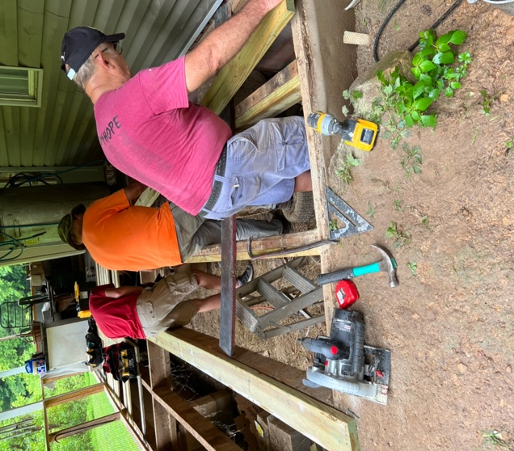

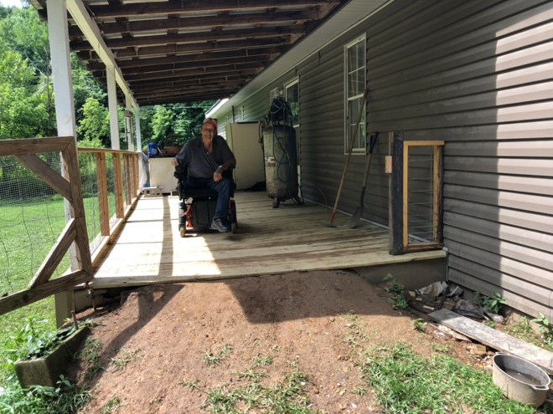

Our first project was removing ½ of a deck,

adding support to the joists and adding new

deck boards.

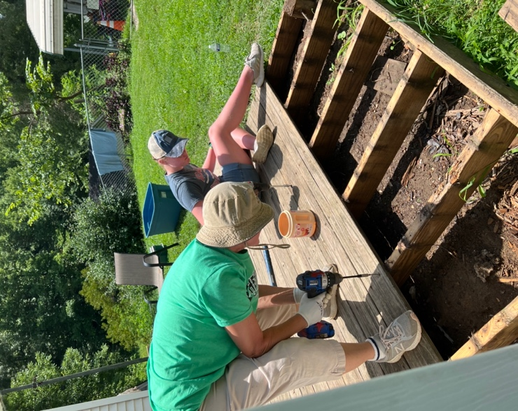

Our second project was to remove a deck,

add support beams and replace it with new deck boards.

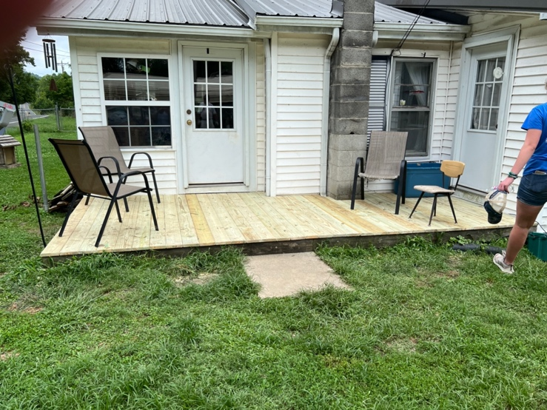

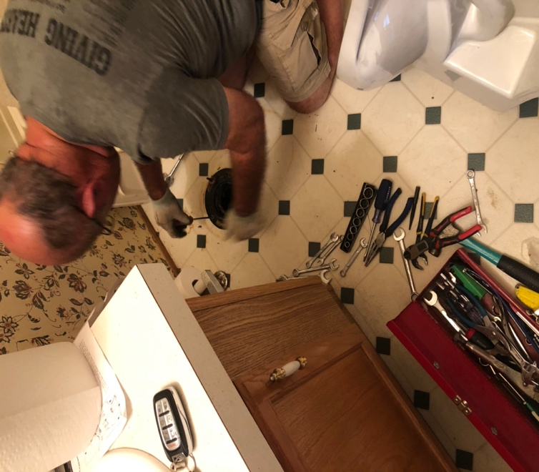

Our third project was to replace two toilets

That were leaking. Water had to be turned

off between flushes.

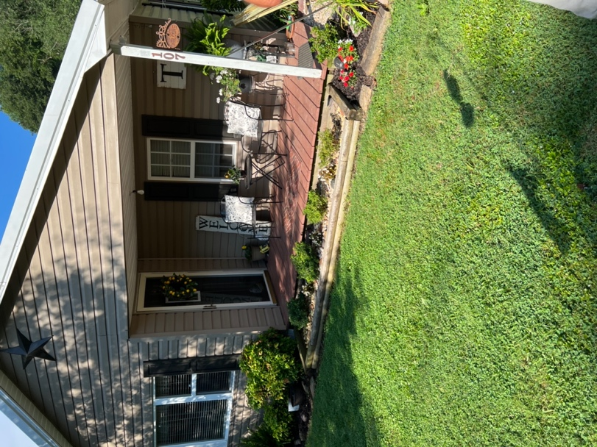

Our fourth project was to install a deck rail.

